SPRINT-2

|  |  |
| --- | --- |
| TEAM ID | PNT2022TMID24757 |
| Project Name | IoT Based smart crop Protection system for agriculture |
| Maximum mark | 20 marks |

STEP1: Download and Install NODE JS.

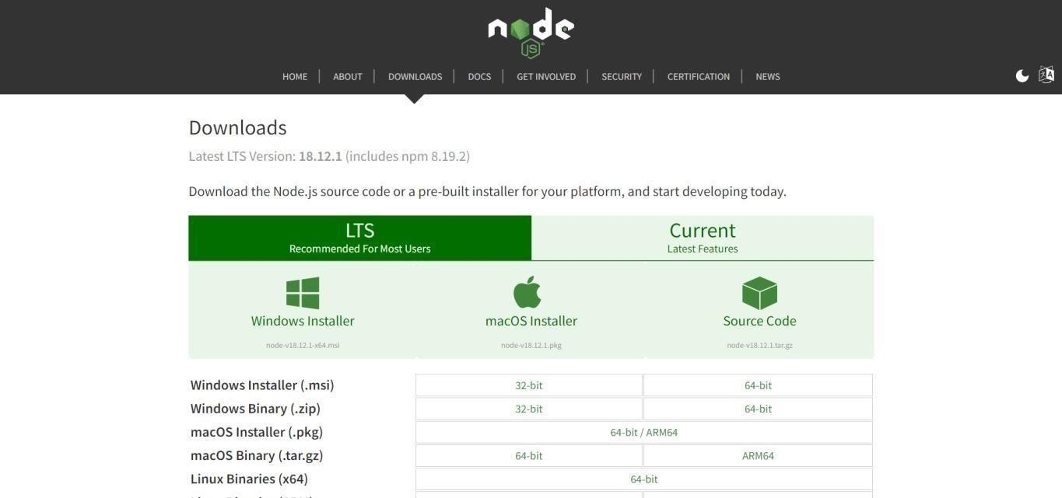

STEP2: Setup node.js and configure command prompt for error check. Open node-red from the generated link.

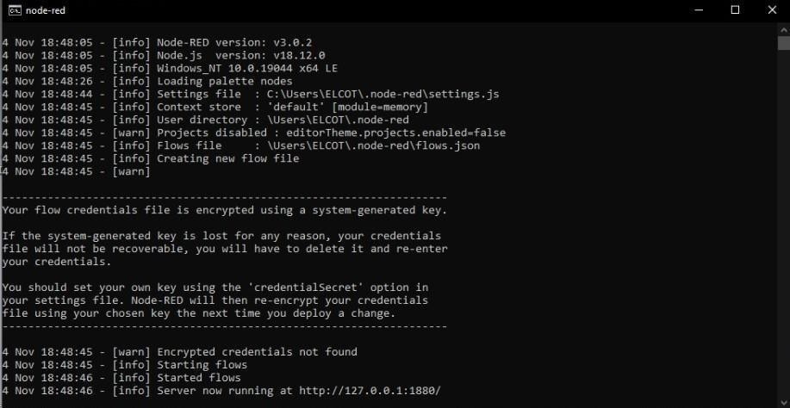

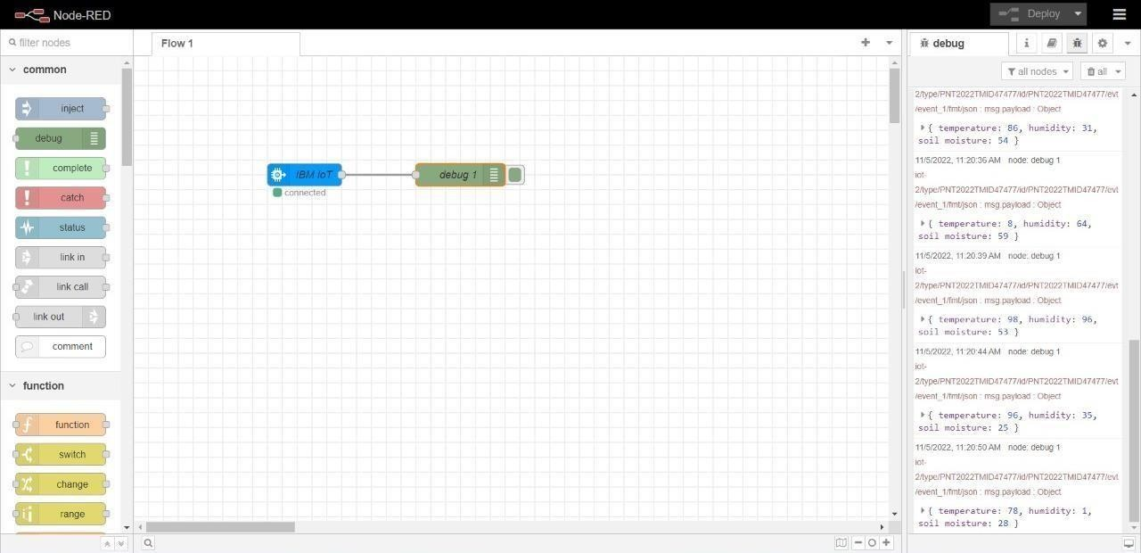STEP3: Connect IBM IOT in and Debug 1 and Deploy.

STEP4: Edit gauge node (Here the gauge nodes are named as Temperature, Humidity and Soil moisture).

